WARP GATE MANUAL

In order to execute WARP GATE, you’d better to follow these steps.

1. Download Chrome
2. Find the Chrome icon on the desk 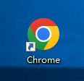
3. Right click the Chrome icon to select the Properties like this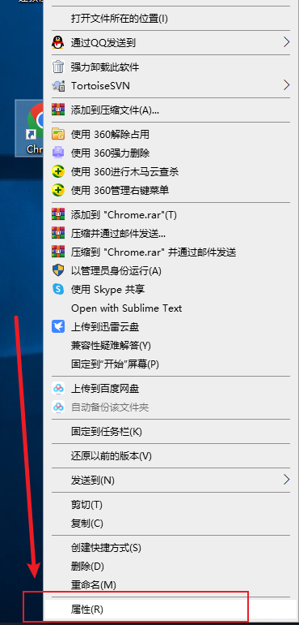
4. To modify the Target info. Add a line --allow-file-access-from-files --user-data-dir="C:\MyChromeUserData" --disable-web-security behind the origin Target 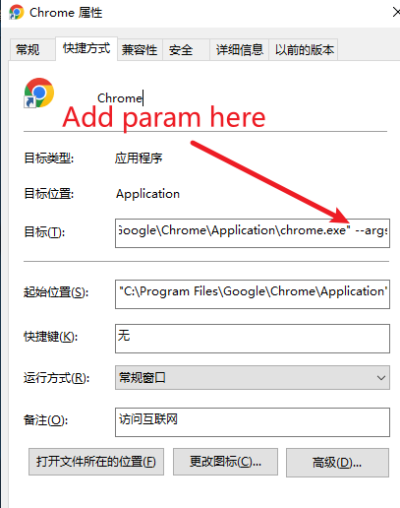(Attention:there are have a blank here)
5. Then save your change 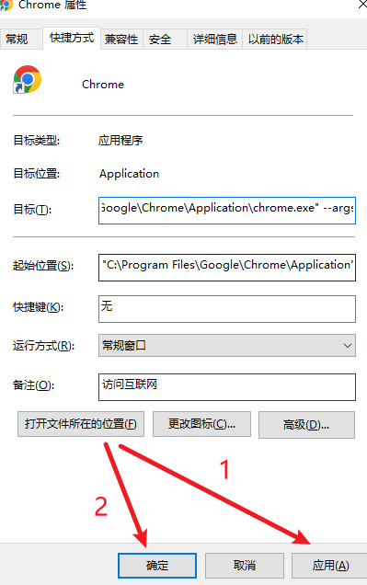

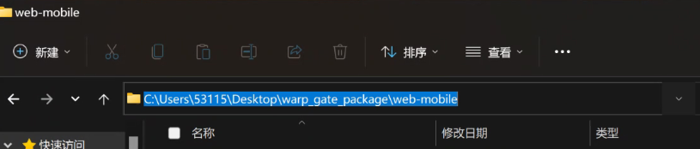

Our prepare work is over, now let’s go ahead

1. Please open our file 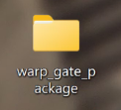
2. Please open the file web-mobile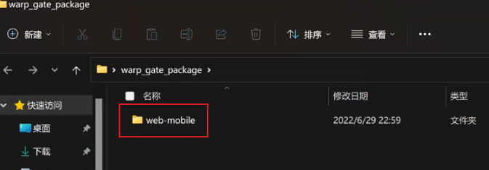
3. Then you will get the window like this 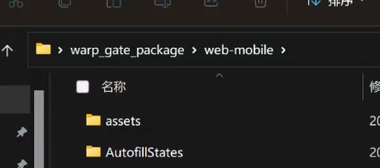
4. Please left click the file address bar 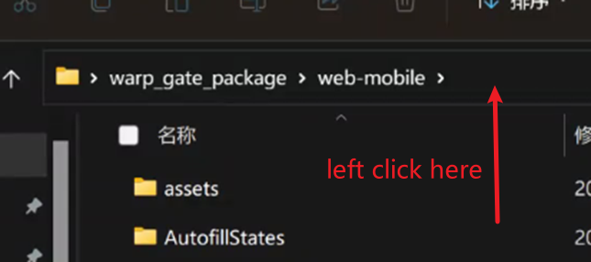
5. Please do a copy 
6. Open the Chrome which we just modify
7. Please paste our copy to the chrome’s search bar and add \index.html 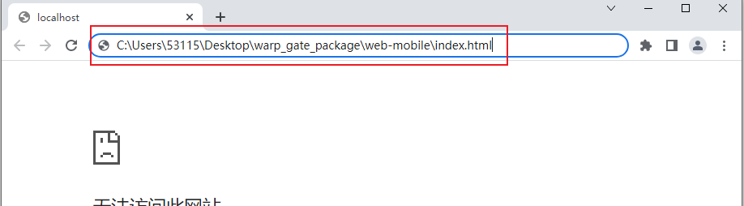
8. Enter and then run our game “WARP GATE”